# Amazon Elastic Compute Cloud - EC2

Launching EC2 is a 7 step process

AWS Marketplace: Build on AWS Platform

Create your own:

Register Snapshot as an AMI

Repeatability, Reusability, Recoverability

EC2 Image Builder

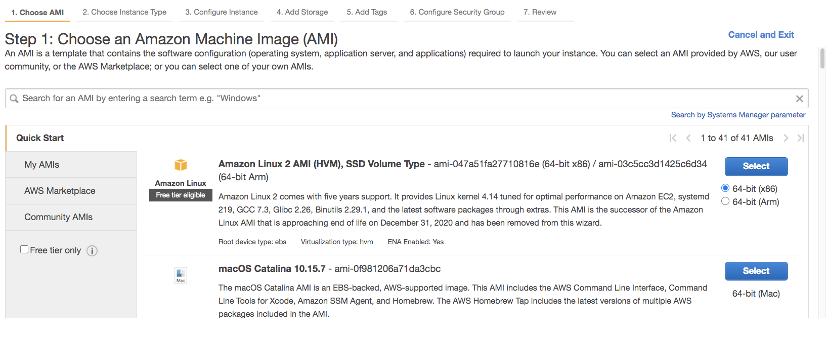

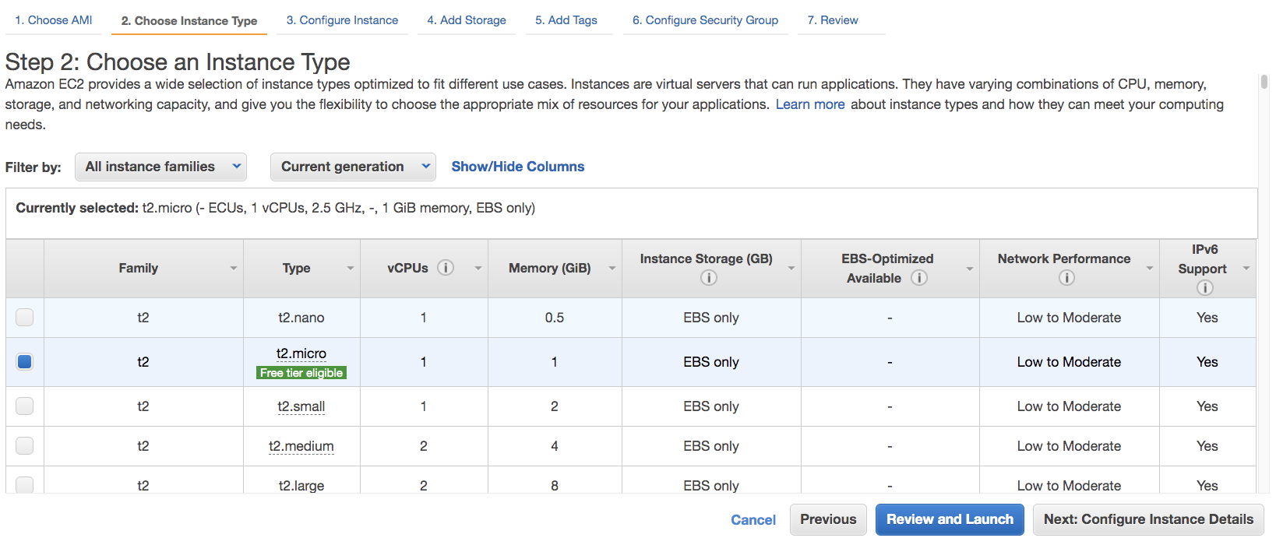

Do not select Request Spot instances, this is just for understanding.

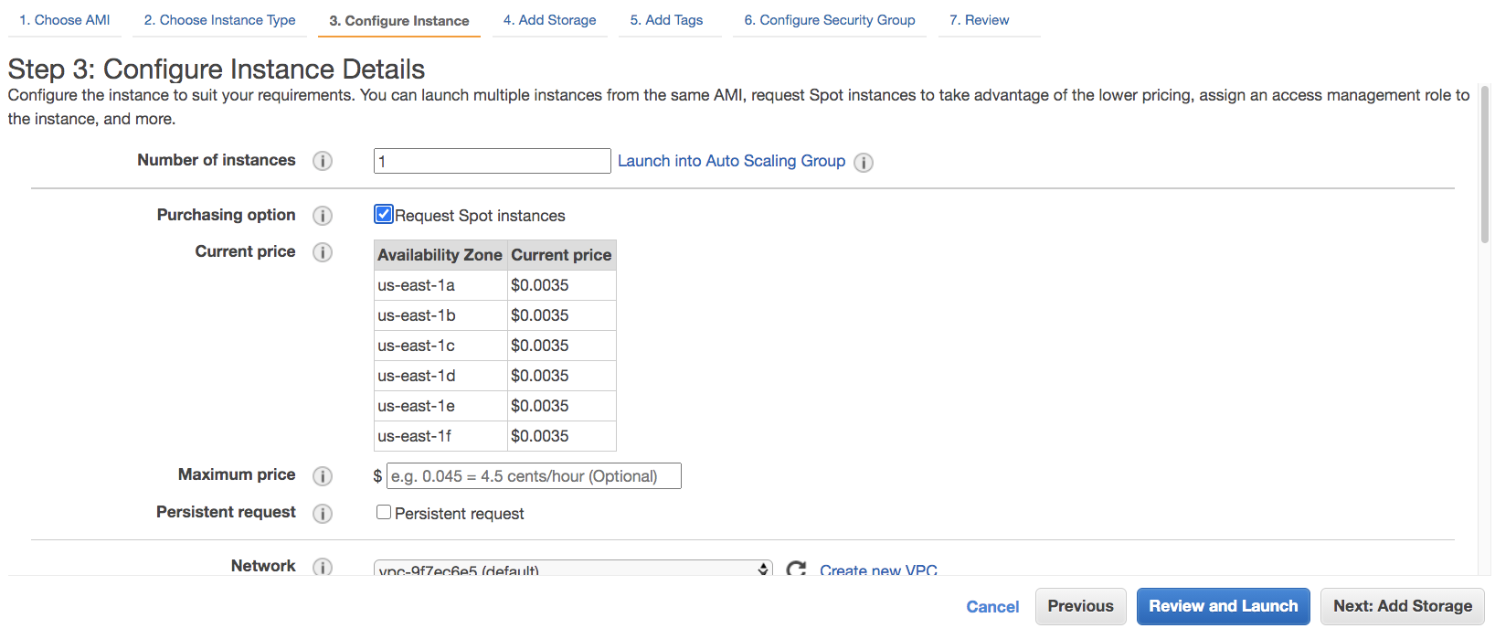

Add here the bootstrap

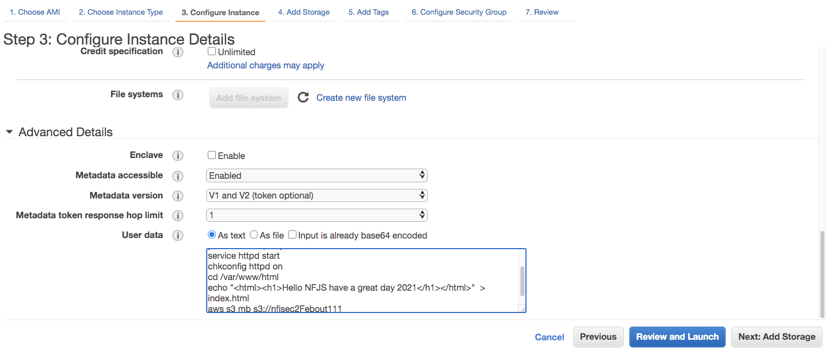

UserData: You can specify user data to configure an instance or run a configuration script during launch. If you launch more than one instance at a time, the user data is available to all the instances in that reservation. => Instance started and then the script is run

<nfjsec2out<Name>>

#!/bin/bash

yum update -y

yum install httpd -y

service httpd start

chkconfig httpd on

cd /var/www/html

echo "<html><h1>Hello NFJS have a great day April 2021</h1></html>" > index.html

aws s3 mb s3://nfjsec2out111<yourname>

aws s3 cp index.html s3://nfjsec2out111<yourname>

======

<http://169.254.169.254/latest/meta-data/>

https://docs.aws.amazon.com/AWSEC2/latest/UserGuide/instancedata-data-retrieval.html

======

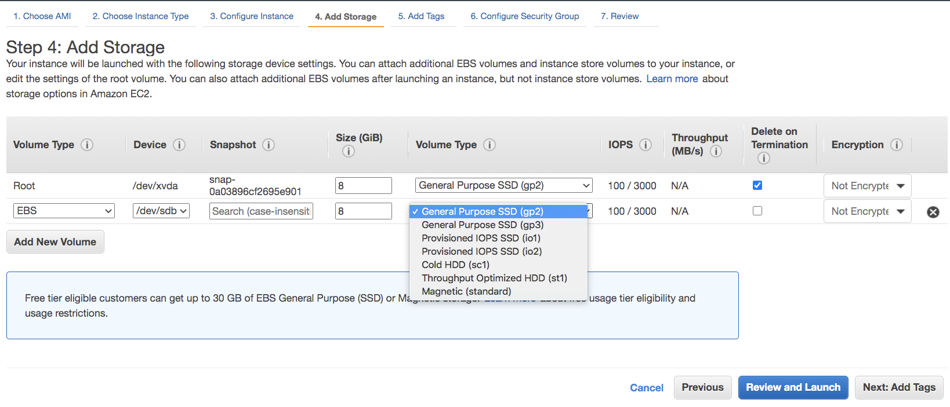

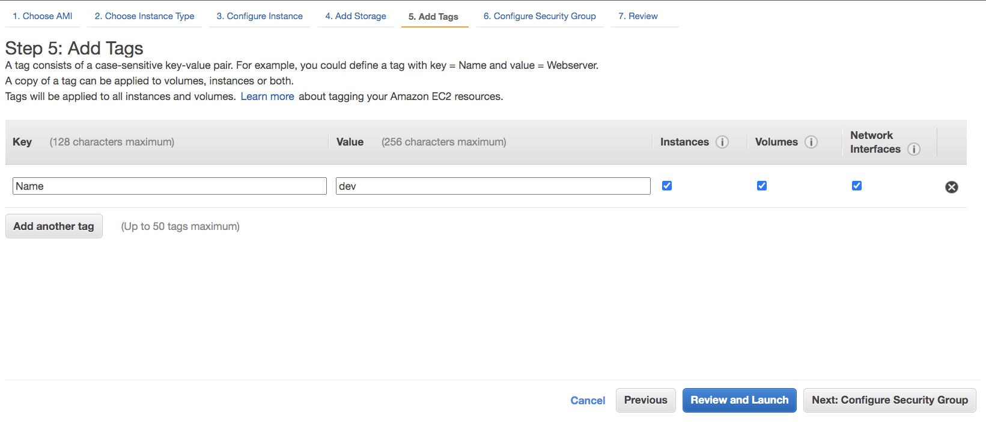

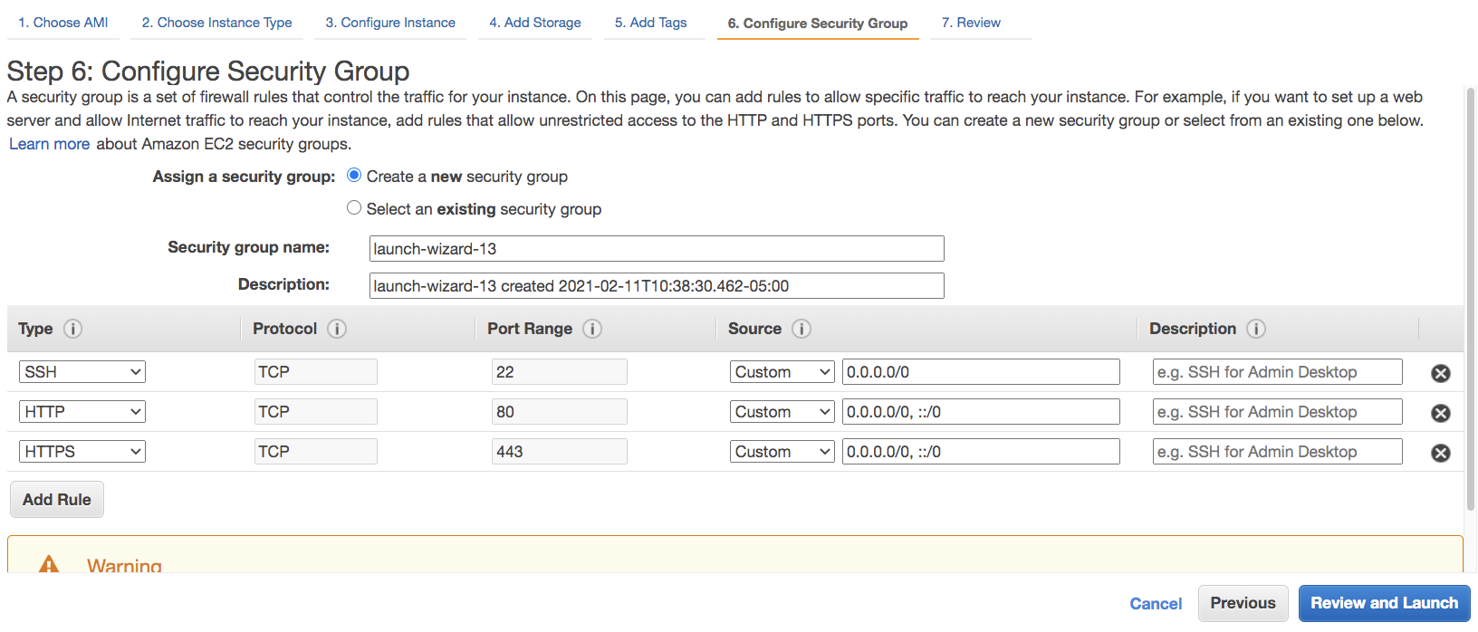

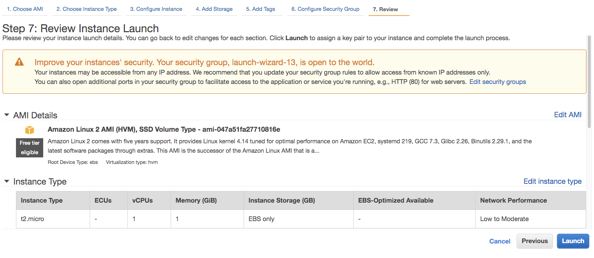

## Steps

Create the EC2 Instance

Download Key Pairs

chmod 400 nfjsec2.pem

